Optimization Basics in Machine Learning

Optimization is one of the core mathematical foundations of Machine Learning. Almost every ML algorithm can be viewed as an optimization problem:

- Conceptual: What are we optimizing and why?
- Mathematical: How do gradients, derivatives, and update rules work?
- Practical: How do algorithms such as Gradient Descent, SGD, Momentum and Adam train ML models?

1. What is Optimization?
Suppose we have a machine-learning model:
$$\hat{y}=f\left(x ; θ\right)$$
where:
- $x$= input
- $y$= actual output
- $\hat{y}$= predicted output
- $θ$= model parameters
The model initially has arbitrary parameter values.
We want to find the parameter values that produce the smallest prediction error.
Therefore, we define a loss function:
$$L\left(θ\right)$$
and try to solve:
$$\boxed{θ^{*}=\arg{\min_{θ}}L\left(θ\right)}$$
Here:
- $θ^{*}$= optimal parameters
- $\arg{min}$= parameter values that produce minimum loss.

Simple example
Suppose:
$$L\left(w\right)={\left(w-3\right)}^{2}$$
We want to find $w$such that $L\left(w\right)$is minimum.
Clearly:
$$w=3$$
gives:
$$L\left(3\right)=0$$
Therefore:
$$\boxed{w^{*}=3}$$
This is an optimization problem.

2. Why is Optimization Important in ML?
Consider a linear regression model:
$$\hat{y}=wx+b$$
Suppose we have:
x | y
1 | 3
2 | 5
3 | 7
We want to find $w$and $b$.
The ideal relationship is:
$$y=2x+1$$
Therefore:
$$w=2, b=1$$
But in a real dataset containing millions of observations and hundreds of features, manually finding the parameters is usually impossible.
Optimization algorithms automatically search for good parameter values.

3. Basic Optimization Terminology
Before studying optimization algorithms, understand these terms.

3.1 Objective Function
The function that we want to optimize.
For minimization:
$$\min_{θ}f\left(θ\right)$$
For maximization:
$$\max_{θ}f\left(θ\right)$$
In ML, the objective is often a loss or cost function.

3.2 Loss Function
Loss measures how wrong a model's prediction is for an individual example.
For example, Mean Squared Error:
$$L={\left(y-\hat{y}\right)}^{2}$$
If:
$$y=10, \hat{y}=8$$
then:
$$L={\left(10-8\right)}^{2}=4$$

4. Loss vs Cost vs Objective
These terms are sometimes used interchangeably, but conceptually they can be distinguished.

Loss
Error for one training example:
$$L_{i}$$

Cost
Average loss over the training dataset:
$$J\left(θ\right)=\frac{1}{n}\sum_{i=1}^{n}{L_{i}}$$

Objective
General mathematical quantity being optimized.
For example:
$$J\left(θ\right)+λR\left(θ\right)$$
where $R$is a regularization term.

5. Parameters and Hyperparameters
This distinction is extremely important.

Parameters
Learned automatically during training.
Examples:
- weights
- biases
- neural-network parameters
For example:
$$\hat{y}=w_{1}x_{1}+w_{2}x_{2}+b$$
Here:
$$w_{1},w_{2},b$$
are parameters.

Hyperparameters
Chosen before or during training.
Examples:
- learning rate
- batch size
- number of epochs
- regularization strength
- number of hidden layers
For example:
$$η=0.01$$
where $η$is the learning rate.

6. Optimization Problem in Machine Learning
A general ML optimization problem can be written as:
$$\boxed{θ^{*}=\arg{\min_{θ}}\left[\frac{1}{n}\sum_{i=1}^{n}{L}\left(y_{i} , f\left(x_{i} ; θ\right)\right)\right]}$$
With regularization:
$$\boxed{θ^{*}=\arg{\min_{θ}}\left[\frac{1}{n}\sum_{i=1}^{n}{L}\left(y_{i} , f\left(x_{i} ; θ\right)\right)+λR\left(θ\right)\right]}$$
This equation is fundamental to ML.

7. A Story to Understand Optimization
Imagine you are standing on a mountain at night.
You want to reach the lowest point in the valley.
But you cannot see the entire landscape.
You can only feel the slope under your feet.
So you repeatedly:
- Check the slope.
- Determine which direction goes downhill.
- Take a small step.
- Check again.
- Continue until the slope becomes nearly flat.
This is essentially the idea behind:

Gradient Descent

8. Derivatives and Optimization
The derivative tells us how a function changes.
Consider:
$$f\left(x\right)=x^{2}$$
Derivative:
$$\frac{df}{dx}=2x$$
At:
$$x=3$$
the derivative is:
$$6$$
Positive derivative means the function increases as $x$increases.
To minimize the function, we need to move in the opposite direction.

9. Critical Point
An optimum often occurs where:
$$\frac{df}{dx}=0$$
For:
$$f\left(x\right)=x^{2}-6x+9$$
we have:
$$\frac{df}{dx}=2x-6$$
Set derivative to zero:
$$2x-6=0$$
Therefore:
$$x=3$$
At $x=3$:
$$f\left(3\right)=0$$
So the minimum occurs at:
$$\boxed{x=3}$$

10. Maximum and Minimum
Consider:
$$f\left(x\right)=x^{2}$$
Graphically it looks like a bowl.
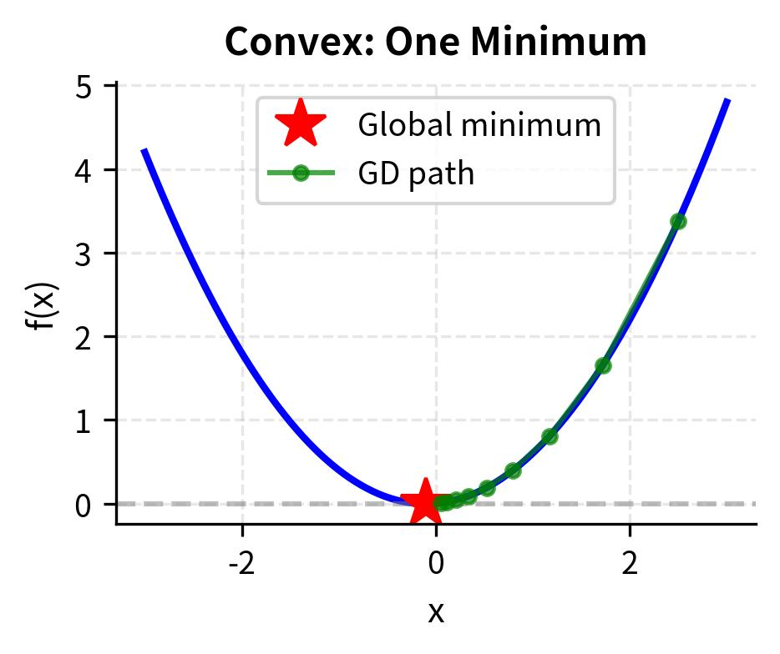
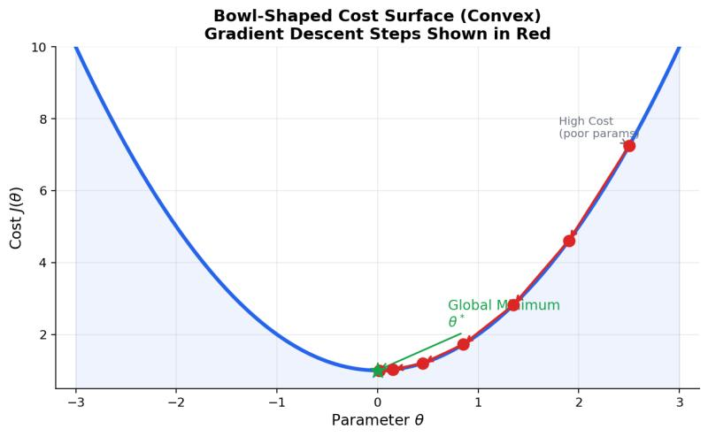
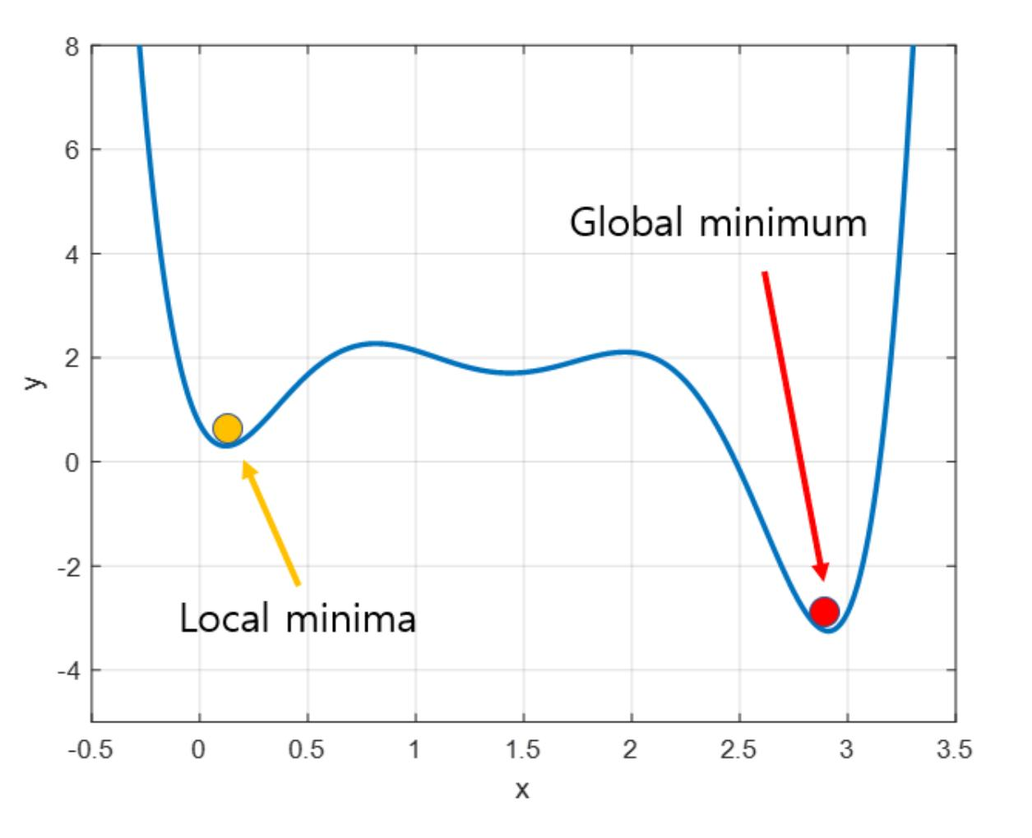
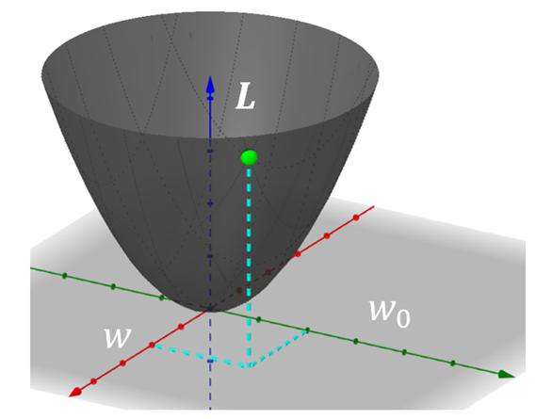
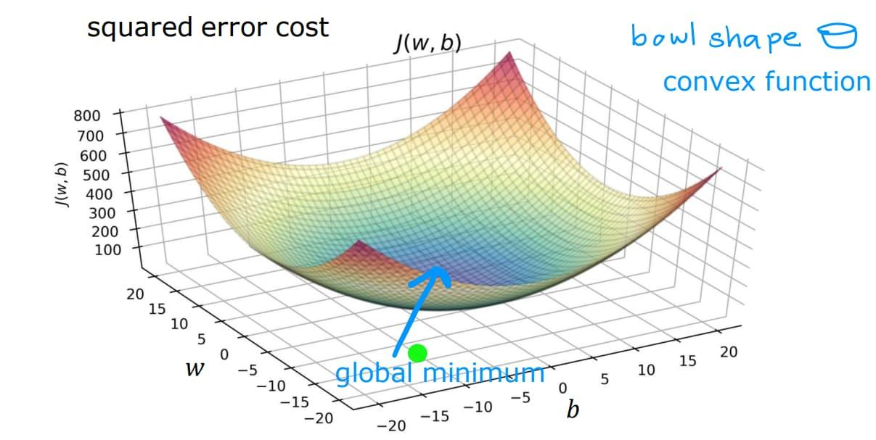
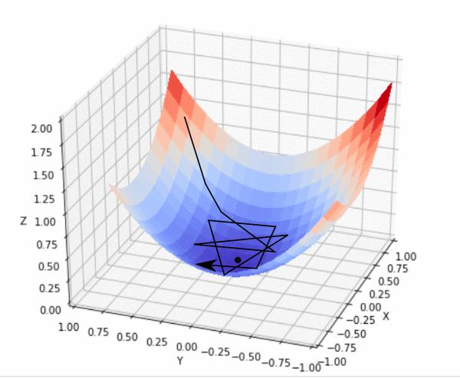
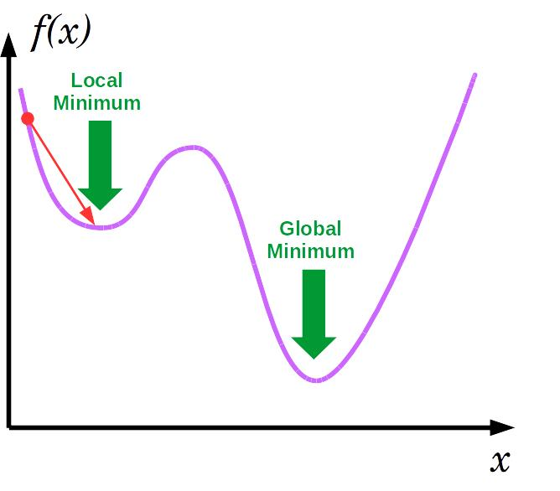
The bottom of the bowl is the minimum.
For:
$$f\left(x\right)=-x^{2}$$
the graph is upside down.
Its highest point is the maximum.

11. Local vs Global Minimum
This is an important examination topic.

Global Minimum
The lowest value of the function over the entire search space.
$$f\left(x^{*}\right)≤f\left(x\right)$$
for every $x$.

Local Minimum
A point that is lower than its immediate neighborhood but may not be the lowest point globally.
Imagine a landscape with several valleys:
/\ /\
/ \ /\ / \
_____/ \___/ \__/ \____
↑ ↑ ↑
local local global
A gradient-based algorithm can sometimes get trapped in a local minimum.

12. Convex and Non-Convex Optimization

Convex Function
A function is convex if it has a bowl-like shape.
For example:
$$f\left(x\right)=x^{2}$$
Important property:
Every local minimum is also a global minimum.
This makes optimization easier.

Non-Convex Function
A non-convex function may contain:
- multiple local minima
- saddle points
- flat regions
- complex landscapes
Neural-network loss functions are generally non-convex.

13. Gradient
For a function of several variables:
$$f\left(x_{1} , x_{2} , … , x_{n}\right)$$
the gradient is:
$$∇f=\left[\begin{matrix}\frac{∂f}{∂x_{1}} \\ \frac{∂f}{∂x_{2}} \\ ⋮ \\ \frac{∂f}{∂x_{n}}\end{matrix}\right]$$
The gradient points in the direction of steepest increase.
Therefore:
$$-∇f$$
points approximately toward the direction of steepest decrease.
That is why Gradient Descent uses:
$$-∇f$$

14. Gradient Descent
The fundamental update equation is:
$$\boxed{θ_{new}=θ_{old}-η∇J\left(θ\right)}$$
where:
- $θ$= parameters
- $J\left(θ\right)$= objective/cost function
- $∇J\left(θ\right)$= gradient
- $η$= learning rate
This is one of the most important equations in ML.

15. Why Do We Subtract the Gradient?
Suppose:
$$J\left(w\right)=w^{2}$$
Then:
$$\frac{dJ}{dw}=2w$$
Suppose:
$$w=5$$
Then:
$$\frac{dJ}{dw}=10$$
The gradient is positive.
To reduce $w$, we move in the negative direction:
$$w_{new}=w-η\left(10\right)$$
Therefore, we subtract the gradient.

16. Numerical: Gradient Descent
Given:
$$J\left(w\right)=w^{2}$$
Initial:
$$w_{0}=5$$
Learning rate:
$$η=0.1$$
Derivative:
$$\frac{dJ}{dw}=2w$$

Iteration 1
$$w_{0}=5$$
Gradient:
$$g_{0}=2\left(5\right)=10$$
Update:
$$w_{1}=5-0.1\left(10\right) \\ \boxed{w_{1}=4}$$

Iteration 2
$$g_{1}=2\left(4\right)=8 \\ w_{2}=4-0.1\left(8\right) \\ \boxed{w_{2}=3.2}$$

Iteration 3
$$g_{2}=2\left(3.2\right)=6.4 \\ w_{3}=3.2-0.1\left(6.4\right) \\ \boxed{w_{3}=2.56}$$
Continue this process.
Eventually:
$$w→0$$
which is the minimum.

17. Learning Rate
The learning rate determines how large a step the optimization algorithm takes.
Usually represented by:
$$η$$

Very small learning rate
Minimum
↓
----->----->----->----->---->
Training may be very slow.

Appropriate learning rate
----> ----> ----> ↓
minimum

Very large learning rate
↓
----> <----
jumps around
The algorithm may overshoot the minimum.

18. Learning Rate Example
Suppose:
$$J\left(w\right)=w^{2}$$
and:
$$w=5$$
Gradient:
$$10$$

Learning rate = 0.01
$$w_{new}=5-0.01\left(10\right)=4.9$$
Small movement.

Learning rate = 0.1
$$w_{new}=4$$
Reasonable movement.

Learning rate = 1
$$w_{new}=-5$$
It jumps across the minimum.

Learning rate = 2
$$w_{new}=5-20=-15$$
It may diverge.

19. Batch Gradient Descent
In Batch Gradient Descent, the gradient is calculated using the entire training dataset.
For $n$examples:
$$J\left(θ\right)=\frac{1}{n}\sum_{i=1}^{n}{L_{i}}$$
Then:
$$θ=θ-η∇J\left(θ\right)$$

Advantages
- Stable gradient
- Smooth convergence
- Useful for smaller datasets

Disadvantages
- Computationally expensive
- Requires processing entire dataset for every update

20. Stochastic Gradient Descent
Instead of using the entire dataset, SGD uses one training example at a time.
Update:
$$\boxed{θ=θ-η∇L_{i}\left(θ\right)}$$
Suppose there are:
$$100,000$$
training examples.
Batch GD processes all 100,000 before an update.
SGD can update after every example.

Advantages
- Faster updates
- Can handle large datasets
- Noise can sometimes help escape shallow local regions

Disadvantages
- Noisy updates
- Loss fluctuates
- May not converge smoothly

21. Mini-Batch Gradient Descent
Mini-batch GD combines the advantages of Batch GD and SGD.
Instead of:
- entire dataset
- one example
we use a small batch.
For example:
$$B=32$$
or:
$$B=64$$
or:
$$B=128$$
Update:
$$θ=θ-η\frac{1}{B}\sum_{i=1}^{B}{∇}L_{i}\left(θ\right)$$
This is the most common optimization strategy in modern deep learning.

22. Comparison
Method | Data per update | Stability | Speed
Batch GD | Entire dataset | High | Slow for large data
SGD | 1 sample | Low | Fast updates
Mini-Batch GD | Small batch | Moderate/High | Efficient

23. Epoch, Batch and Iteration
These terms frequently appear in ML exams.
Suppose:
$$N=10,000$$
training examples.
Batch size:
$$B=100$$
Then:
$$\frac{10,000}{100}=100$$
updates are required for one complete pass through the dataset.
Therefore:

1 epoch
= one complete pass through the training data.

1 iteration
= one parameter update.

1 batch
= examples used in one iteration.

24. Numerical on Epochs
Dataset:
$$N=10,000$$
Batch size:
$$100$$
Epochs:
$$20$$
Iterations per epoch:
$$\frac{10,000}{100}=100$$
Total iterations:
$$20×100=2000$$
Therefore:
$$\boxed{2000\text{ parameter updates}}$$

25. Gradient Descent for Linear Regression
Consider:
$$\hat{y}=wx+b$$
Mean Squared Error:
$$J\left(w , b\right)=\frac{1}{n}\sum_{i=1}^{n}{(}\left.y_{i}-\left(wx_{i}+b\right){\left.)\right.}^{2}\right.$$
We calculate:
$$\frac{∂J}{∂w}$$
and:
$$\frac{∂J}{∂b}$$
The update equations are:
$$w←w-η\frac{∂J}{∂w} \\ b←b-η\frac{∂J}{∂b}$$
Thus optimization learns both:
- slope $w$
- intercept $b$

26. Deriving Gradient for Linear Regression
Let:
$${\hat{y}}_{i}=wx_{i}+b$$
and:
$$J=\frac{1}{n}\sum_{i=1}^{n}{(}\left.y_{i}-{\hat{y}}_{i}{\left.)\right.}^{2}\right.$$
Substitute:
$$J=\frac{1}{n}\sum_{i=1}^{n}{[}\left.y_{i}-\left(wx_{i}+b\right){\left.]\right.}^{2}\right.$$
Derivative with respect to $w$:
$$\boxed{\frac{∂J}{∂w}=-\frac{2}{n}\sum_{i=1}^{n}{x_{i}}\left(y_{i}-{\hat{y}}_{i}\right)}$$
Derivative with respect to $b$:
$$\boxed{\frac{∂J}{∂b}=-\frac{2}{n}\sum_{i=1}^{n}{(}\left.y_{i}-{\hat{y}}_{i}\right)}$$
Then:
$$w←w-η\frac{∂J}{∂w} \\ b←b-η\frac{∂J}{∂b}$$

27. Optimization and Logistic Regression
Logistic regression predicts:
$$p\left(y=1∣x\right)=σ\left(z\right)$$
where:
$$z=w^{T}x+b$$
and:
$$σ\left(z\right)=\frac{1}{1+e^{-z}}$$
The commonly used loss is Binary Cross Entropy:
$$J=-\frac{1}{n}\sum_{i=1}^{n}{[}\left.y_{i}\log{p_{i}}+\left(1-y_{i}\right)log⁡\left(1-p_{i}\right)\right]$$
Optimization finds:
$$w^{*},b^{*}$$
that minimize this loss.

28. Optimization in Neural Networks
This is where optimization becomes particularly important.
Suppose a neural network has:
$$1,000,000$$
parameters.
We need to find:
$$θ_{1},θ_{2},…,θ_{1,000,000}$$
that minimize:
$$J\left(θ\right)$$
The neural network uses:
- Forward propagation
- Loss calculation
- Backpropagation
- Gradient calculation
- Optimization update
The overall cycle is:
Input
↓
Forward Propagation
↓
Prediction
↓
Loss
↓
Backpropagation
↓
Gradients
↓
Optimizer
↓
Updated Weights
↓
Repeat

29. Backpropagation vs Optimization
These are related but not the same thing.

Backpropagation
Calculates gradients:
$$\frac{∂J}{∂w}$$

Optimization
Uses those gradients to update parameters.
For example:
$$w_{new}=w-η\frac{∂J}{∂w}$$
So:
Backpropagation tells us which direction to move. Optimization decides how to move.
This distinction is very important.

30. Momentum
Standard gradient descent can sometimes move inefficiently.
Momentum introduces a velocity term.
A common formulation is:
$$v_{t}=βv_{t-1}+\left(1-β\right)g_{t}$$
and:
$$θ_{t}=θ_{t-1}-ηv_{t}$$
where:
- $v_{t}$= accumulated velocity
- $g_{t}$= current gradient
- $β$= momentum coefficient
- $η$= learning rate
Typical:
$$β≈0.9$$

Intuition
Imagine pushing a heavy ball downhill.
Once it starts moving, it carries some momentum.
This can help optimization move faster through shallow regions.

31. AdaGrad
AdaGrad adapts the learning rate separately for each parameter.
Basic idea:
$$G_{t}=G_{t-1}+g_{t}^{2}$$
Then:
$$θ_{t}=θ_{t-1}-\frac{η}{\sqrt{G_{t}+ϵ}}g_{t}$$
Parameters with frequently occurring large gradients receive smaller effective learning rates.
Parameters with smaller or infrequent gradients can receive relatively larger updates.

32. RMSProp
RMSProp improves upon AdaGrad by using an exponentially weighted moving average.
$$s_{t}=βs_{t-1}+\left(1-β\right)g_{t}^{2}$$
Then:
$$\boxed{θ_{t}=θ_{t-1}-\frac{η}{\sqrt{s_{t}+ϵ}}g_{t}}$$
It avoids AdaGrad's aggressive accumulation of squared gradients.

33. Adam Optimizer
Adam stands for:
Adaptive Moment Estimation
Adam combines ideas from:
- Momentum
- RMSProp
First moment:
$$m_{t}=β_{1}m_{t-1}+\left(1-β_{1}\right)g_{t}$$
Second moment:
$$v_{t}=β_{2}v_{t-1}+\left(1-β_{2}\right)g_{t}^{2}$$
Bias correction:
$${\hat{m}}_{t}=\frac{m_{t}}{1-β_{1}^{t}} \\ {\hat{v}}_{t}=\frac{v_{t}}{1-β_{2}^{t}}$$
Update:
$$\boxed{θ_{t}=θ_{t-1}-η\frac{{\hat{m}}_{t}}{\sqrt{{\hat{v}}_{t}}+ϵ}}$$
Common default values historically include:
$$β_{1}=0.9 \\ β_{2}=0.999 \\ ϵ={10}^{-8}$$

34. Adam Intuition
Think of Adam as asking two questions:

Question 1
"What direction have my gradients generally been pointing?"
→ Momentum / first moment.

Question 2
"How large have the gradients generally been?"
→ second moment.
Adam uses both pieces of information to adjust parameter updates.

35. Optimizer Comparison
Optimizer | Main Idea
GD | Follow negative gradient
SGD | Gradient using one example
Mini-Batch GD | Gradient using small batch
Momentum | Accumulate previous direction
AdaGrad | Adaptive parameter-specific learning rate
RMSProp | Moving average of squared gradients
Adam | Momentum + adaptive scaling

36. Saddle Points
A saddle point is a point that is:
- minimum in one direction
- maximum in another direction
For example:
$$f\left(x , y\right)=x^{2}-y^{2}$$
At:
$$\left(0 , 0\right)$$
the function is neither a maximum nor minimum.
This is a saddle point.
Saddle points can create difficulties for optimization in high-dimensional models.

37. Local Minima in Neural Networks
Neural-network loss surfaces can be highly complex.
They may contain:
- local minima
- saddle points
- plateaus
- steep regions
- flat regions
However, an important practical point is that modern neural-network optimization is not simply a story of "gradient descent always gets trapped in bad local minima." In high-dimensional networks, saddle points and flat/ill-conditioned regions can be especially important.

38. Vanishing and Exploding Gradients
Deep neural networks use repeated chain-rule multiplication.
If gradients repeatedly multiply by numbers smaller than 1:
$$0.5×0.5×0.5⋯$$
the gradient can become extremely small.
This is:
$$\boxed{\text{Vanishing Gradient}}$$
If gradients repeatedly multiply by numbers greater than 1:
$$2×2×2⋯$$
they can become extremely large.
This is:
$$\boxed{\text{Exploding Gradient}}$$

39. How to Address Gradient Problems
Common approaches include:

Vanishing gradients
- ReLU-type activations
- appropriate initialization
- normalization techniques
- residual connections
- LSTM/GRU for certain sequence problems

Exploding gradients
- gradient clipping
- appropriate initialization
- normalization
- suitable learning rates

40. Gradient Clipping
Suppose:
$$∣∣g∣∣=100$$
but we want maximum norm:
$$5$$
Then scale the gradient:
$$g^{'}=g\frac{5}{100}$$
Therefore:
$$∣∣g^{'}∣∣=5$$
This prevents extremely large updates.
Gradient clipping is particularly useful in some recurrent neural-network training settings.

41. Feature Scaling and Optimization
Feature scaling can greatly affect optimization.
Suppose:
$$x_{1}∈\left[0 , 1\right]$$
but:
$$x_{2}∈\left[0 , 1 , 000 , 000\right]$$
The optimization landscape can become badly conditioned.
Gradient descent may move inefficiently.
Scaling features can make optimization easier.

42. Standardization
A common transformation is:
$$z=\frac{x-μ}{σ}$$
where:
- $μ$= mean
- $σ$= standard deviation
After standardization, features approximately have:
$$μ=0$$
and:
$$σ=1$$

43. Min-Max Scaling
Another option:
$$x^{'}=\frac{x-x_{min}}{x_{max}-x_{min}}$$
This typically maps values into:
$$\left[0 , 1\right]$$
Feature scaling does not change the underlying task, but it can make numerical optimization much more efficient.

44. Regularization and Optimization
Sometimes minimizing training error alone leads to overfitting.
We can modify the objective:
$$J\left(θ\right)=Loss\left(θ\right)+λR\left(θ\right)$$
where:
$$R\left(θ\right)$$
penalizes undesirable parameter configurations.

45. L1 Regularization
L1 penalty:
$$R\left(θ\right)=\sum_{j}{∣}θ_{j}∣$$
Therefore:
$$J=Loss+λ\sum_{j}{∣}θ_{j}∣$$
L1 regularization can encourage many coefficients to become exactly zero.
This can produce sparse models.

46. L2 Regularization
L2 penalty:
$$R\left(θ\right)=\sum_{j}{θ_{j}^{2}}$$
Therefore:
$$J=Loss+λ\sum_{j}{θ_{j}^{2}}$$
L2 regularization discourages excessively large weights.

47. Optimization with Constraints
Some optimization problems have constraints.
General form:
$$\min_{θ}f\left(θ\right)$$
subject to:
$$g_{i}\left(θ\right)≤0$$
and:
$$h_{j}\left(θ\right)=0$$
Example:
$$\min_{x}x^{2}$$
subject to:
$$x≥2$$
Without the constraint:
$$x^{*}=0$$
But $x=0$violates the constraint.
Therefore the constrained optimum is:
$$\boxed{x^{*}=2}$$

48. Lagrange Multipliers
For equality constraints, we can form the Lagrangian:
$$L\left(x , λ\right)=f\left(x\right)+λg\left(x\right)$$
For example:
$$\min_{x}x^{2}$$
subject to:
$$x-2=0$$
Lagrangian:
$$L=x^{2}+λ\left(x-2\right)$$
Then solve:
$$\frac{∂L}{∂x}=0$$
and:
$$\frac{∂L}{∂λ}=0$$
This provides the constrained optimum.

49. Learning Rate Scheduling
Using the same learning rate throughout training is not always ideal.
We can gradually reduce it.
For example:
$$η_{t}=\frac{η_{0}}{1+kt}$$
where:
- $η_{0}$= initial learning rate
- $k$= decay factor
- $t$= iteration
Other approaches include:
- step decay
- exponential decay
- cosine schedules
- warm-up
- plateau-based reduction

50. Why Learning Rate Scheduling Helps
At the beginning:
Large steps can help move quickly toward a useful region.
Later:
Smaller steps can help refine the solution.
Conceptually:
Beginning End

BIG STEPS SMALL STEPS

------->------> --> --> . . .
↓
minimum

51. Batch Size and Optimization
Batch size affects optimization behavior.

Small batch
Advantages:
- frequent updates
- lower memory requirement
- noisy gradients

Large batch
Advantages:
- efficient hardware utilization
- smoother gradients
- potentially more memory consumption
The choice affects:
- convergence behavior
- memory
- training speed
- generalization behavior
There is no universally optimal batch size for every ML problem.

52. Stopping Criteria
Optimization must eventually stop.
Common stopping conditions:

1. Maximum epochs
$$Epochs=100$$

2. Gradient becomes small
$$∣∣∇J∣∣<ϵ$$

3. Loss improvement becomes small
$$∣J_{t}-J_{t-1}∣<ϵ$$

4. Validation performance stops improving
This is commonly implemented through:

Early Stopping

53. Early Stopping
Suppose training proceeds:
Epoch | Training Loss | Validation Loss
1 | 0.80 | 0.82
2 | 0.60 | 0.65
3 | 0.45 | 0.52
4 | 0.35 | 0.48
5 | 0.28 | 0.47
6 | 0.22 | 0.49
7 | 0.18 | 0.55
Training loss continues decreasing.
But validation loss begins increasing.
This indicates increasing overfitting.
We may stop around the point where validation performance was best.

54. Numerical: One-Dimensional Optimization
Given:
$$f\left(x\right)=x^{2}-4x+4$$
Find the minimum.
First derivative:
$$f^{'}\left(x\right)=2x-4$$
Set:
$$2x-4=0$$
Therefore:
$$x=2$$
Second derivative:
$$f^{''}\left(x\right)=2$$
Since:
$$f^{''}\left(x\right)>0$$
the point is a minimum.
Function value:
$$f\left(2\right)=4-8+4=0$$
Therefore:
$$\boxed{x^{*}=2, f\left(x^{*}\right)=0}$$

55. Numerical: Gradient Descent
Given:
$$f\left(x\right)={\left(x-4\right)}^{2}$$
Initial:
$$x_{0}=0$$
Learning rate:
$$η=0.25$$
Derivative:
$$f^{'}\left(x\right)=2\left(x-4\right)$$

Iteration 1
$$g_{0}=2\left(0-4\right)=-8 \\ x_{1}=0-0.25\left(-8\right) \\ \boxed{x_{1}=2}$$

Iteration 2
$$g_{1}=2\left(2-4\right)=-4 \\ x_{2}=2-0.25\left(-4\right) \\ \boxed{x_{2}=3}$$

Iteration 3
$$g_{2}=2\left(3-4\right)=-2 \\ x_{3}=3-0.25\left(-2\right) \\ \boxed{x_{3}=3.5}$$
The values move toward:
$$\boxed{x=4}$$

56. A More ML-Like Numerical
Suppose:
$$\hat{y}=wx$$
Training example:
$$x=2, y=10$$
Initial:
$$w=1$$
Prediction:
$$\hat{y}=1\left(2\right)=2$$
Squared loss:
$$L={\left(y-\hat{y}\right)}^{2} \\ L={\left(10-2\right)}^{2}=64$$
Derivative:
$$\frac{∂L}{∂w}=-2x\left(y-wx\right)$$
Therefore:
$$=-2\left(2\right)\left(10-2\right) \\ =-32$$
Learning rate:
$$η=0.01$$
Update:
$$w_{new}=1-0.01\left(-32\right) \\ \boxed{w_{new}=1.32}$$
The weight increased because the model was underpredicting.

57. Optimization Landscape
An optimization landscape represents:
- parameters on the horizontal axes
- loss on the vertical axis
For two parameters:
$$J\left(w_{1} , w_{2}\right)$$
we can visualize a 3D surface or contour plot.
Gradient descent attempts to move through this landscape toward lower loss.
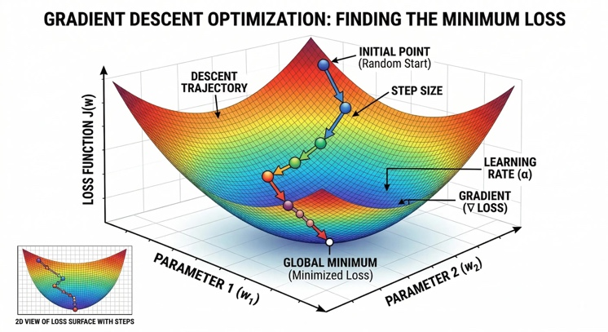
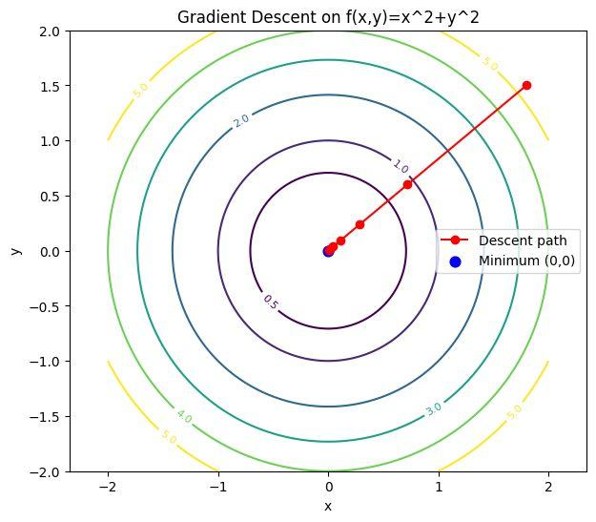
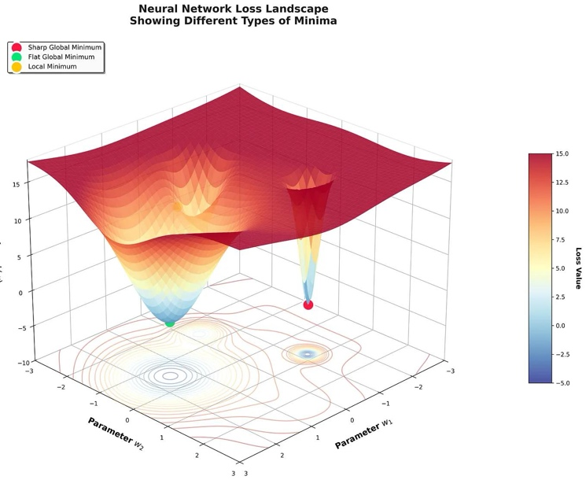
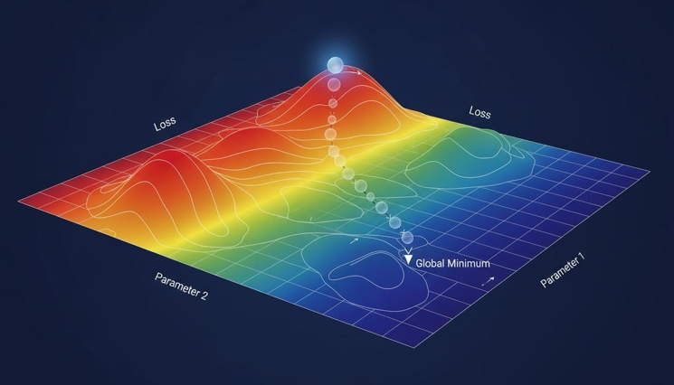
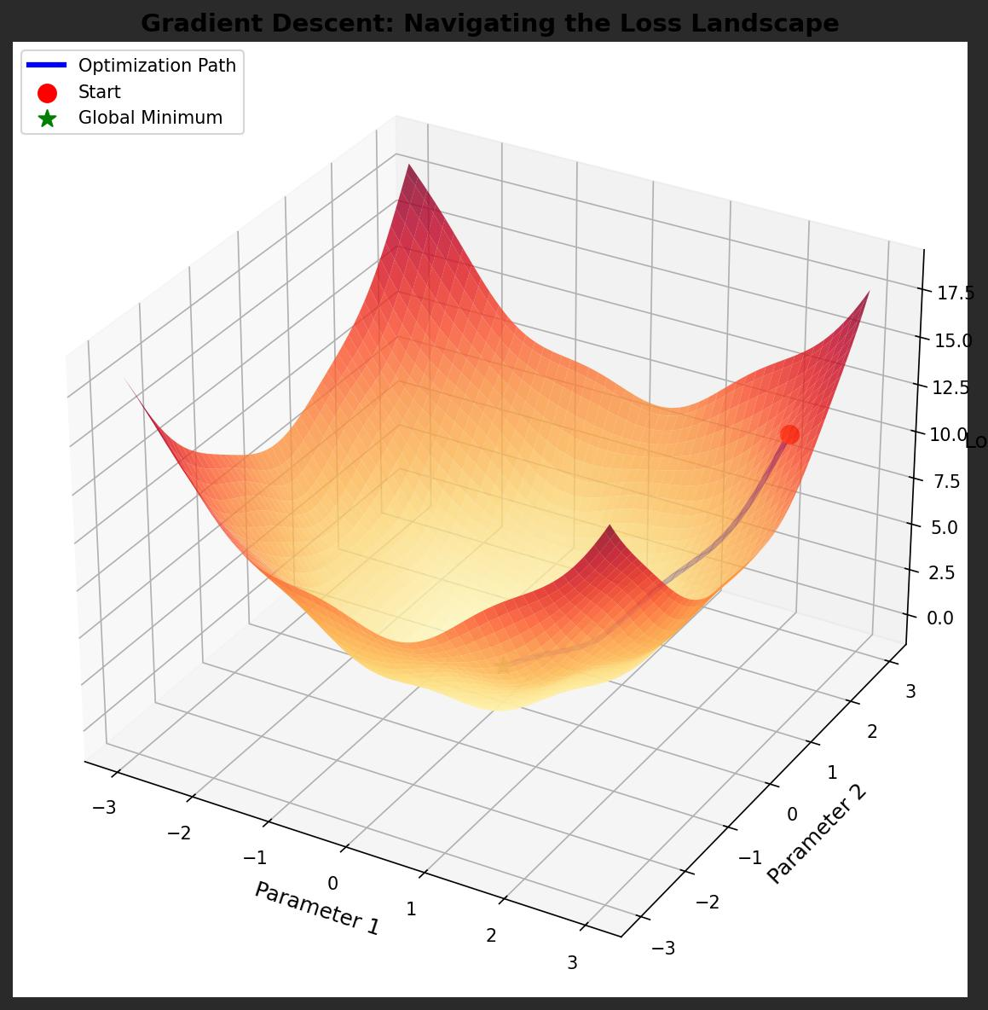
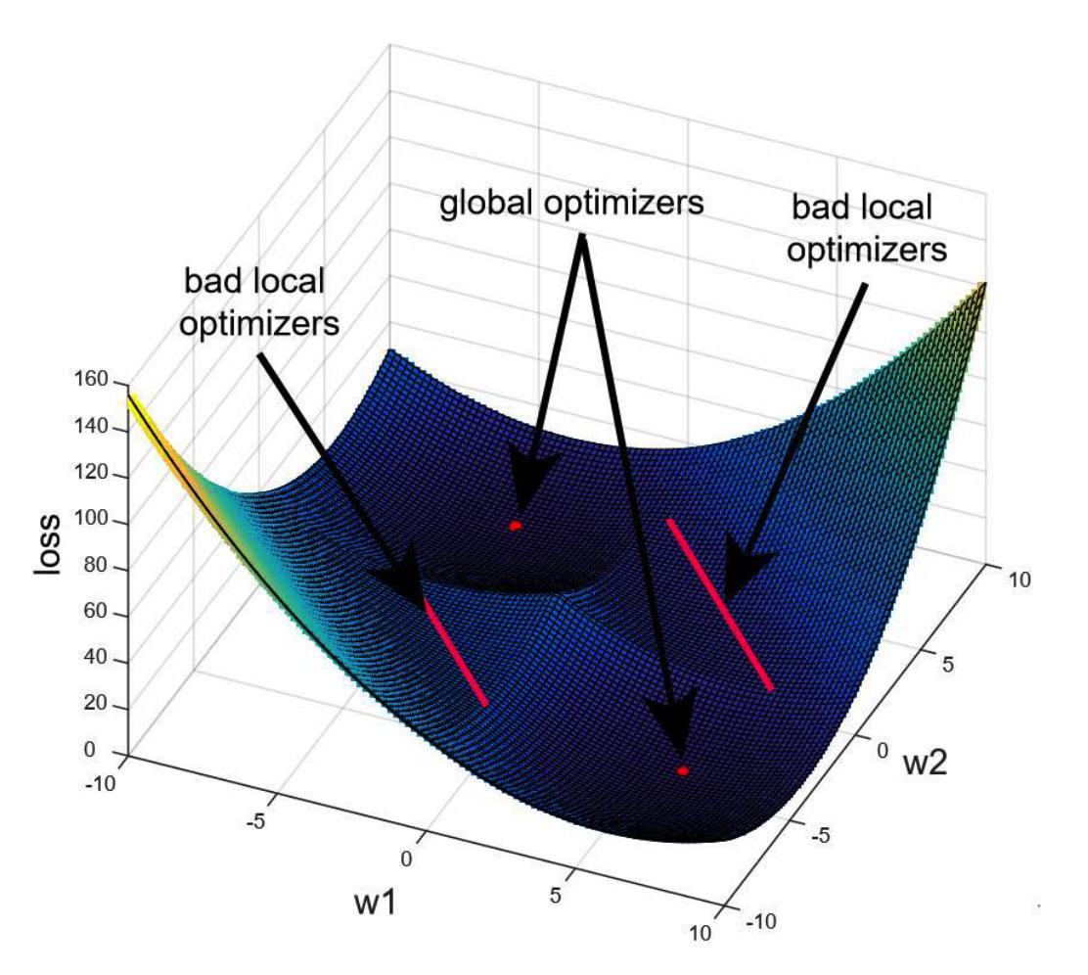

58. Ill-Conditioned Optimization
Consider a very elongated valley:
\ /
\ /
\ /
\_______/
The gradient can repeatedly bounce across the narrow valley.
This can make optimization slow.
Feature scaling and adaptive optimizers can help in such situations.

59. First-Order vs Second-Order Optimization

First-Order Methods
Use the first derivative:
$$∇J$$
Examples:
- Gradient Descent
- SGD
- Momentum
- Adam
These are widely used in deep learning.

Second-Order Methods
Use the Hessian:
$$H=∇^{2}J$$
Examples:
- Newton's method
- Quasi-Newton methods
- BFGS
- L-BFGS
They can use curvature information but may be computationally expensive for very high-dimensional neural networks.

60. Newton's Method
For one variable:
$$x_{new}=x-\frac{f^{'}\left(x\right)}{f^{''}\left(x\right)}$$
Compared with gradient descent:
$$x_{new}=x-ηf^{'}\left(x\right)$$
Newton's method uses both:
- slope
- curvature
It can converge very quickly near a suitable optimum.

61. Hessian Matrix
For:
$$f\left(x_{1} , x_{2}\right)$$
the Hessian is:
$$H=\left[\begin{matrix}\frac{∂^{2}f}{∂x_{1}^{2}} & \frac{∂^{2}f}{∂x_{1}∂x_{2}} \\ \frac{∂^{2}f}{∂x_{2}∂x_{1}} & \frac{∂^{2}f}{∂x_{2}^{2}}\end{matrix}\right]$$
It describes the curvature of the function.
Think:
- Gradient → slope/direction
- Hessian → curvature

62. Gradient Descent vs Newton's Method
Feature | Gradient Descent | Newton
Uses gradient | Yes | Yes
Uses Hessian | No | Yes
Memory requirement | Lower | Higher
Computation | Lower | Higher
Common in deep learning | Very common | Less common
Curvature information | No | Yes

63. Optimization and Generalization
Optimization does not mean:
"Make training loss as small as mathematically possible."
The real goal of ML is usually:
Learn a model that performs well on unseen data.
Therefore, we care about both:
$$Training Loss$$
and:
$$Validation/Test Performance$$
This is why:
- regularization
- early stopping
- appropriate model complexity
- data augmentation
- hyperparameter tuning
can matter.

64. Hyperparameter Optimization
There are two levels of optimization.

Level 1: Model Optimization
Learn parameters:
$$θ$$
using an optimizer such as Adam.

Level 2: Hyperparameter Optimization
Find good values for:
- learning rate
- batch size
- regularization strength
- number of layers
- hidden units
Methods include:
- Grid Search
- Random Search
- Bayesian Optimization

65. Grid Search
Suppose we want to test:
$$Learning Rate:\left\{0.001 , 0.01 , 0.1\right\}$$
and:
$$Batch Size:\left\{32 , 64\right\}$$
Total combinations:
$$3×2=6$$
We train six configurations and compare validation performance.

66. Random Search
Instead of systematically trying every combination, randomly sample configurations.
This can be more efficient when only a few hyperparameters strongly influence performance.

67. Bayesian Optimization
Bayesian optimization builds a model of the relationship:
$$Hyperparameters→Validation Performance$$
It uses previous experiments to decide which configuration to test next.
This can reduce expensive model-training experiments.

68. Common Optimization Problems in ML

Problem 1: Learning rate too high
Possible result:
- oscillation
- divergence
- unstable loss

Problem 2: Learning rate too low
Possible result:
- very slow convergence

Problem 3: Poorly scaled features
Possible result:
- slow/inefficient optimization

Problem 4: Exploding gradients
Possible result:
- extremely large updates
- numerical instability

Problem 5: Vanishing gradients
Possible result:
- extremely slow learning in some layers

Problem 6: Overfitting
Possible result:
- training loss decreases
- validation performance worsens

69. Practical Optimization Workflow
A practical ML workflow can be:
1. Prepare data
↓
2. Split train/validation/test
↓
3. Scale/transform features where appropriate
↓
4. Select model
↓
5. Define loss
↓
6. Select optimizer
↓
7. Choose learning rate
↓
8. Train
↓
9. Monitor training + validation
↓
10. Tune hyperparameters
↓
11. Early stopping / checkpointing
↓
12. Evaluate on test data

70. Complete Optimization Pipeline
The entire ML optimization process can be summarized as:
$$\boxed{Data→Model→Prediction→Loss→Gradient→Optimizer→Updated Parameters→Repeat}$$
This cycle is repeated many times.

71. Important Formulas for Examination

Basic optimization
$$\boxed{θ^{*}=\arg{\min_{θ}}J\left(θ\right)}$$

Gradient
$$\boxed{∇J=\left[\begin{matrix}\frac{∂J}{∂θ_{1}} \\ ⋮ \\ \frac{∂J}{∂θ_{n}}\end{matrix}\right]}$$

Gradient descent
$$\boxed{θ_{t+1}=θ_{t}-η∇J\left(θ_{t}\right)}$$

Mini-batch gradient
$$\boxed{g_{t}=\frac{1}{B}\sum_{i=1}^{B}{∇}L_{i}}$$

Momentum
$$\boxed{v_{t}=βv_{t-1}+\left(1-β\right)g_{t}}$$

Adam
$$\boxed{θ_{t}=θ_{t-1}-η\frac{{\hat{m}}_{t}}{\sqrt{{\hat{v}}_{t}}+ϵ}}$$

L1 regularization
$$\boxed{J=Loss+λ\sum{∣}θ∣}$$

L2 regularization
$$\boxed{J=Loss+λ\sum{θ^{2}}}$$

Newton's method
$$\boxed{x_{new}=x-\frac{f^{'}\left(x\right)}{f^{''}\left(x\right)}}$$

72. Quick Conceptual Differences

Loss vs Optimizer
Loss: tells us how wrong the model is.
Optimizer: determines how model parameters should change to reduce the loss.

Gradient vs Gradient Descent
Gradient: direction of steepest increase.
Gradient Descent: algorithm that moves opposite to the gradient.

Backpropagation vs Optimizer
Backpropagation: computes gradients.
Optimizer: uses gradients to update weights.

Parameter vs Hyperparameter
Parameter: learned from data.
Hyperparameter: selected by the practitioner/training procedure.

Batch GD vs SGD
Batch GD: entire dataset per update.
SGD: one example per update.

SGD vs Mini-Batch
SGD: one sample.
Mini-batch: small group of samples.

73. Exam-Oriented Numerical Questions

Question 1
Given:
$$f\left(x\right)=x^{2}-8x+16$$
Find the minimum using differentiation.

Solution
$$f^{'}\left(x\right)=2x-8$$
Set:
$$2x-8=0 \\ x=4$$
Therefore:
$$f\left(4\right)=0$$
Answer:
$$\boxed{x=4}$$

Question 2
Given:
$$f\left(x\right)=x^{2}$$
with:
$$x_{0}=10, η=0.1$$
Perform two Gradient Descent iterations.
Derivative:
$$f^{'}\left(x\right)=2x$$
First:
$$x_{1}=10-0.1\left(20\right)=8$$
Second:
$$x_{2}=8-0.1\left(16\right)=6.4$$
Therefore:
$$\boxed{x_{1}=8, x_{2}=6.4}$$

74. Exam-Oriented Theory Questions

Short-answer questions
- Define optimization in machine learning.
- What is an objective function?
- What is a loss function?
- Define gradient.
- What is Gradient Descent?
- Explain learning rate.
- Differentiate Batch GD and SGD.
- What is mini-batch Gradient Descent?
- What is momentum?
- What is Adam?
- What is a saddle point?
- Explain local and global minima.
- What is a convex function?
- What is regularization?
- Explain L1 and L2 regularization.
- What is early stopping?
- What is gradient clipping?
- Explain vanishing gradients.
- Explain exploding gradients.
- What is the Hessian matrix?

75. Long-Answer / M.Tech Exam Questions

Question 1
Explain Gradient Descent in detail. Derive its update rule and demonstrate the algorithm using a numerical example.

Question 2
Compare Batch Gradient Descent, Stochastic Gradient Descent and Mini-Batch Gradient Descent with respect to computational cost, convergence behavior and practical applications.

Question 3
Explain Momentum, AdaGrad, RMSProp and Adam. Give their mathematical update equations and explain their differences.

Question 4
Explain the role of optimization in training a neural network. Discuss forward propagation, loss computation, backpropagation and parameter updates.

Question 5
Explain convex and non-convex optimization with suitable mathematical examples.

Question 6
Discuss the problems of vanishing and exploding gradients and explain techniques used to address them.

Question 7
Explain L1 and L2 regularization from an optimization perspective.

Question 8
Compare first-order and second-order optimization methods.

76. One Complete Mental Model
If you remember only one story for the entire chapter, remember this:
The model is a student trying to solve a question.
Loss function tells the student how many mistakes they made.
Gradient tells the student which direction their mistakes are increasing.
Gradient Descent tells them to move in the opposite direction.
Learning rate tells them how big a step to take.
Momentum tells them to remember the direction they were already moving.
Adam combines direction history with adaptive step sizes.
Regularization tells them not to make the model unnecessarily complicated.
Early stopping tells them when to stop studying because continued memorization is hurting performance on new questions.
So the central idea is:
$$\boxed{\text{Prediction}→\text{Loss}→\text{Gradient}→\text{Parameter Update}→\text{Better Prediction}}$$
and this repeats until the model reaches a satisfactory solution.

77. Final Revision Sheet
For an M.Tech ML exam, make sure you can explain these 15 topics without looking at notes:
- Optimization problem
- Objective/loss/cost function
- Parameters and hyperparameters
- Derivative and gradient
- Local vs global minimum
- Convex vs non-convex optimization
- Gradient Descent
- Learning rate
- Batch, SGD and Mini-Batch GD
- Momentum
- AdaGrad
- RMSProp
- Adam
- Regularization and constrained optimization
- Optimization issues: saddle points, vanishing/exploding gradients, early stopping
The single most important equation to remember is:
$$\boxed{θ_{t+1}=θ_{t}-η∇J\left(θ_{t}\right)}$$
Almost everything else in basic ML optimization can be understood as an extension, modification, or practical improvement of this idea.

